

**FASHION SHOP ONLINE**

**Project Assignment Solution**

# I. Overview

## 1*. Introduction*

The online clothing shopping system is a new Web application that replaces the real-life selection processes, making it easier for customers to choose and to pay conveniently. With a diverse product development system, customers do not have to go to the place to choose but can stay at home and comfortably choose for themselves suitable models.. This system is expected to develop after updates with new features and promises to be completed as soon as possible to introduce to consumers

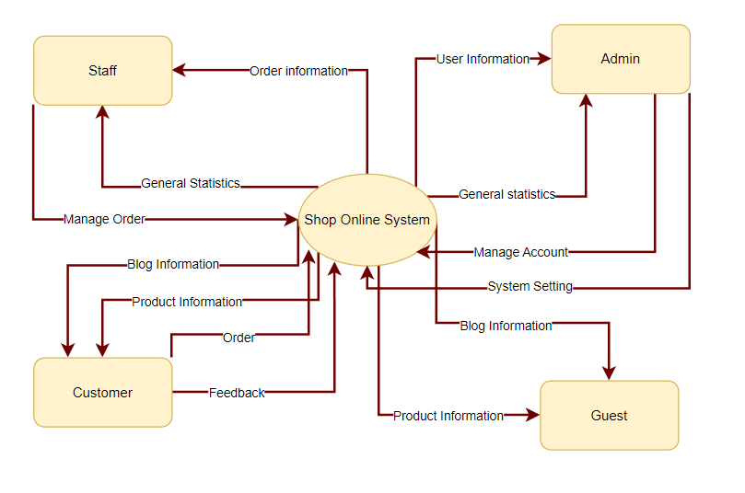

## 2. System Functions

#### a. Screen Flow

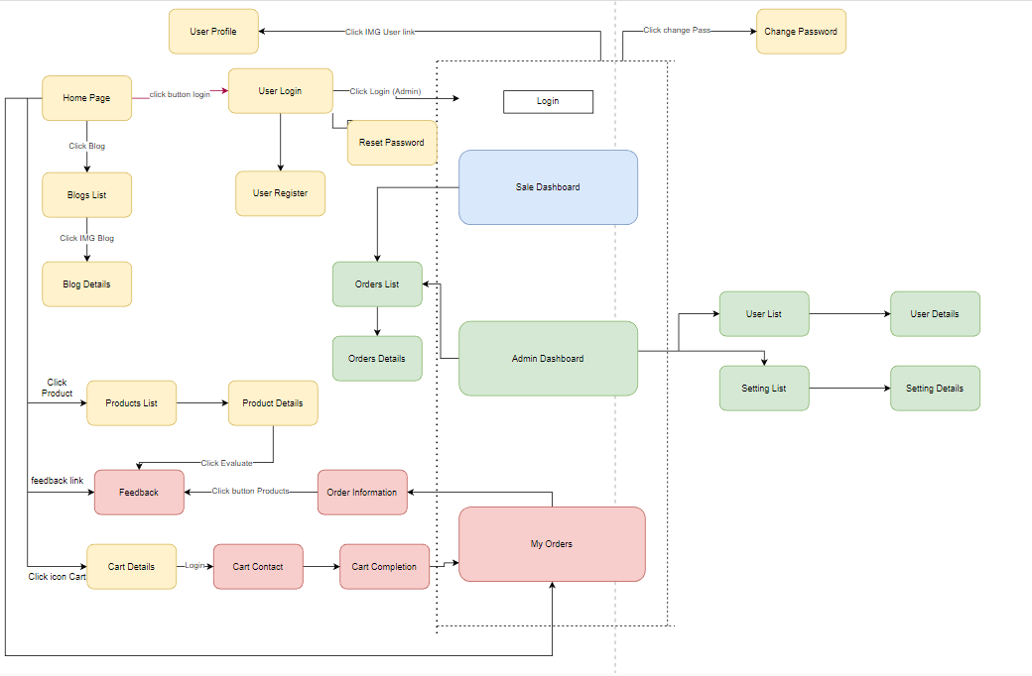

#### b. Screen Details

| **No.** | **Feature** | **Screen** | **Description** |
| --- | --- | --- | --- |
| 1 | Public | Home Page | Show sliders, hot posts, featured products + the slider with the latest posts, static contacts/links |
| - Shown slider information includes its image and title; the user is redirected to the slider's backlink on his/her clicking |
| - Shown post information includes its thumbnail, title, brief-info; the user is redirected to the post's details on his/her clicking |
| - Shown product information includes its thumbnail, title, brief information; the user is redirected to the product's details on his/her clicking |
| 2 | Public | Blogs List | This is a pop-up screen which allows the user to enter email & password to login; on this page, there are also links for user to register new information or reset the password for the case s/he forget it |
| 3 | Public | Blog Details | This is a pop-up screen which allows the user to register to the system by inputting following information: full name, user title (Mr, Mrs, Ms,..), email, mobile, address; User then needs to verify by clicking the link sent via email to him/her before being able to access the system |
| 4 | Public | Products List | The user input his/her email to receive the reset password link. This link is sent to the user's email for his/her password resetting. |
| - On clicking the link, the user is redirected to the password resetting page in which s/he input new password (twice) for the system access |
| - Note that the link is only available for a specific time duration as configured in the system config file. |
| 5 | Public | Product Details | Implementation of authorization mechanism in the system, including the specify the role of logged-in user, his/her authorized page links (building the displayed menu items (in the front end) and preventing unauthorized access via enter the links directly) |
| 6 | Public | Cart Details | This is a pop-up screen which allows the user to edit his/her profile information, including the registered ones & the avatar image. Please note that s/he is not allowed to change the email. |
| 7 | Public | Cart Contact | This is a pop-up screen which allows the user to change his/her password by inputting his current password as well as new password (twice) |
| 8 | Public | Cart Completion | Show the posts pagination (sorted by updated date, paginated) + the cider with the post search box, post categories, the latest posts, and static contacts/links; Shown post information includes its thumbnail, title, brief-info; the user is redirected to the post's details on his/her clicking |
| 9 | Public | Feedback | Show post details (including title, author, updated date, category, and post details) + the cider with the post search box, post categories, static contacts/links |
| 10 | Common | User Login | Show the paginated list of posts (include posts' id, thumbnail, title, category, author, featured, and status information): |
| - The user can filter the post by category, author, status or search by title |
| - Sortable by title, category, author, featured, or status |
| - From each post, the user can choose to hide, show, view, edit it |
| - The page also have the button/link that allows the user to add new post |
| 11 | Common | User Register | Show detailed post information (thumbnail, category, title, brief information, content, flag to turn the featurning on/off, status), from that allow the user to input new post information, view or edit existing post information |
| 12 | Common | Reset Password | Show the paginated list of sliders (including sliders' id, title, image, backlink, status) |
| - The user can filter the sliders by the status + search by title or backlink |
| - For each slider, the user can choose to hide, show, edit it |
| 13 | Common | Change Password | Show detailed slider information (image, title, backlink, status, notes) |
| 14 | Common | User Profile | Show the paginated list of registered users (include users' id, full name, gender, email, mobile, role, status): |
| - The admin can filter the users by gender, role, status |
| - Allow the admin to search users by full name, email, mobile |
| - The list is sortable by id, fullname, gender, email, mobile, role, status |
| - From each user, the admin can choose to view or edit it |
| - The page also have the button/link that allows the admin to add new user |
| 15 | Common | User Authorization | Show detailed user information (avatar, full name, gender, email, mobile, role, address, status), from that allow the user to add new, view or edit user information |
| - After adding, new generated login password would be email to the new user |
| - The admin can only edit/update the role and status of the user |
| Show detailed user information (type, value, order, description, status), from that allow the user to add new, view or edit setting information |
| 16 | Customer | My Orders | Show the products paginated (sorted by updated date) + the slider with the product search box, product categories, the latest products, and static contacts/links; |
| - Shown product information includes its thumbnail, title, brief information, original price, and sale price; |
| - The user is redirected to the product's details on his/her clicking on the product |
| - The user can choose to add the product to the cart or to feedback on the product by clicking the product's Buy & Feedback buttons responsively |
| 17 | Customer | Order Information | Show product details (including title, category, images, original price, sale price, and product details) + the slider with the product search box, product categories, the latest products, and static contacts/links |
| 18 | Staff and Admin | Sale Dashboard | Show detailed customer/contact information (full name, gender, email, mobile, address, status), from that allow the user to input, view or edit them (except for the status which is generated automatically - contact, potential or customer) |
| Besides, the screen also shows the list of customer/contact changes history in the form of a table which includes following columns: email, full-name, gender, mobile, address, updated by, updated date |
| 19 | Staff and Admin | Orders List | Show the list of feedbacks paginated (include feedbacks' contact full name, product name, rated star, status): |
| - The user can filter the feedbacks by status, product, rated star + search by full name, feedback content |
| - Sortable by full name, product name, rated star, status |
| - From each feedback, the user can choose to view or change it's status |
| 20 | Staff and Admin | Order Details | Show the feedback details (contact full name, email, mobile, product, rated star, feedback, images status) from that allow the user to change its status |
| 21 | Admin | Admin Dashboard | Show the trend of success/total orders, and the revenues trends by day for the last 7 days for all or a specific salesperson (the start date, end date, sale, order status can be adjustable) |
| 22 | Admin | Users List x | Show the list of orders paginated |
| - The list can be shorted by the order date, customer name, total cost, status |
| - Each order include below information: id, ordered date, customer name, product (first product name & number of other products if any), total cost, status; |
| - Allow the users to filter the order by the order date (from, to), sale name, status |
| - Allow the user to search the orders by order id, customer name |
| - On clicking the link under the order id, user would be redirected to the Order Details page |
| 22 | Admin | User Details | Show the order details, including the following information: |
| - Basic order information: order id, customer full name, email, mobile, order date, total cost, sale name, status |
| - The receiver information: full name, gender, email, mobile, address |
| - This list of ordered products, each product include following information: thumbnail, name, category, unit price, quantity, total cost |
| Sale Manager & the assigned Sale can change the order status & the sale notes |
| Sale Manager can assign the order to other sale |
| 23 | Admin | Settings List | Show statistics of new orders (success, canceled, submitted), revenues (total, by product categories), customers (newly registered, newly bought), feedbacks (average star: total, by product categories) & the trend of order counts (success, all) by day for the last 7 days or 1 month (the start date & end date can be adjustable) |
| 24 | Admin | Setting Details | Show the paginated list of settings (include settings' id, type, value, order, status): |
| - The admin can filter the setting by type, status |
| - Allow the admin to search settings by value |
| - The list is sortable by id, type, value, order, status |
| - From each setting, the admin can choose to view, activate/deactivate, or edit it |
| - The page also have the button/link that allows the admin to add new setting |
| 25 | Admin and Staff | Manager Login |  |

#### c. User Authorization

| **Screen** | **Admin** | **Guest** | **Customer** | **Staff** |
| --- | --- | --- | --- | --- |
| Home Page | x | x | x | x |
| Blogs List | x | x | x | x |
| Blog Details | x | x | x | x |
| Products List(Public) | x | x | x | x |
| Product Details(Public) | x | x | x | x |
| Cart Details |  |  | x |  |
| Cart Contact |  |  | x |  |
| Cart Completion |  |  | x |  |
| Feedback |  |  | x |  |
| User Login |  | x | x |  |
| User Register |  | x | x |  |
| Reset Password |  | x | x |  |
| Change Password | x |  | x | x |
| User Profile | x |  | x | x |
| My Orders |  |  | x |  |
| Order Information |  |  | x |  |
| Posts List |  |  |  |  |
| Post Details |  |  |  |  |
| Sliders List |  |  |  |  |
| Slider Details |  |  |  |  |
| Customers List | x |  |  |  |
| Customer Details | x |  |  |  |
| Feedbacks List | x |  |  | x |
| Feedback Details | x |  |  | x |
| Sale Dashboard | x |  |  | x |
| Orders List | x |  |  | x |
| Order Details | x |  |  | x |
| Admin Dashboard | x |  |  |  |
| Users List | x |  |  |  |
| User Details | x |  |  |  |
| Settings List | x |  |  |  |
| Setting Details | x |  |  |  |

In which:

* Admin: the organization leader/manager, acts as the system administrator
* Guest: unregistered users
* Customer: they are registered users who are actual customers or potential customers
* Staff: the members of the organization

#### d. Non-Screen Functions

|  |  |  |  |
| --- | --- | --- | --- |
| **No** | **Feature** | **System Function** | **Description** |
| 1 | Common | Sign out | Users sign out of the system |
| 2 | Common | User Authorization | Authorize user into the system functions based on his/her role |

## 3. Common Requirements

- User Login: This is a pop-up screen which allows the user to enter email & password to login; on this page, there are also options for user to register new information or reset the password for the case s/he forget it

- User Register:This is a pop-up screen which allows the user to register himself/herself to the system by inputting following information: full name, gender, email, mobile, and address; User then need to verify by clicking the link sent via email to him/her before being able to access the system

- Reset Password: The user can input his/her email to receive the reset password link. This link is sent to the user's email for his/her password resetting.

On clicking the link, the user is redirected to the password resetting page in which s/he input new password (twice) for the system access

Note that the link is only available for a specific time duration as configured in the system config file.

- Change Password: This is a pop-up screen which allows the user to change his/her password by inputting his current password as well as new password (twice)

- User Profile: This is a pop-up screen which allows the user to edit his/her profile information, including the registered ones & the avatar image. Please note that s/he is not allowed to change the email

- User Authorization: Implementation of authorization mechanism in the system, including the specify the role of logged-in user, his/her authorized page links (building the displayed menu items (in the front end) and preventing unauthorized access via enter the links directly)

## 4. Database Schema

**Table List**

| **No** | **Table** | **Description** |
| --- | --- | --- |
| 1 | User | userId int ,  fullName nvarchar(50),  password varchar(50),  avatar varbinary(max),  gender bit,  email varchar(50),  mobile varchar(50),  role_id int,  [address] nvarchar(255),  [status] nvarchar(50)  **Primary key: userId**  **Foreign key: role_id** |
| 2 | Role | role_id int,  role_name varchar(50)                status bit  **Primary key: role_id** |
| 3 | Category | category_id int,  category_name nvarchar(50)                 Status bit  **Primary key: category_id** |
| 4 | Product | product_id int,  product_name nvarchar(255),  category_id int,                brief_infor  original_prices float,  sale_prices float,  product_details nvarchar(max),  quantity int,                 status nvarchar,                 update_date date,                 season nvarchar ,  sex  bit,  product_size varchar ,  **Primary key: product_id**  **Foreign key: category_id** |
| 5 | Product_Images | Product_Images_id int,                 Product_id int,  images varchar(max)  **Primary key: statusOrder_id**  **Foreign key: Product_id** |
| 6 | Order | order_id int,                fullName nvarchar(50),  email varchar(50),  mobile varchar(50),                Address nvarchar(255),  orderDate date,  total_cost float,  statusOrder_id int,  user_id int  **Primary key: order_id**  **Foreign key: user_id** |
| 7 | orderDetail | orderDetail_id int,  product_id int,  prices float,  quantity int,  order_id int  **Primary key: orderDetail_id**  **Foreign key:product_id int_id** |
| 8 | Feedback | feedBack_id int,  fullName nvarchar(50),  rated_star float,  feedback nvarchar(max),  image_status varbinary(max),                Status bit,  product_id int,  userId int,  **Primary key: feedBack_id**  **Foreign key: product_id, userId** |
| 9 | categoryBlog | categoryBlog_id int,  categoryBlog_name nvarchar(50),                 Status int  **Primary key: categoryBlog_id** |
| 10 | Blog | blog_id int,  title nvarchar(50),  author_id int,  updated_date date,  content text,                 Thumbnail text,                 Brief_infor nvarchar(255)  categoryBlog_id int,  **Primary key: blog_id**  **Foreign key: author_id, categoryBlog_id** |
| 11 | UpdateCustomer | updateCustomer_id int,  email varchar(50),  fullName nvarchar(50),  Gender bit,  mobile varchar(50),                 Address nvarchar(255)                updated_date date,  updated_by int,  **Primary key: udateCustomer_id**  **Foreign key: updated_by** |
| 12 | Slider | slider_id int,  slider_title nvarchar(50),  Slider_images  text,  Backlink varchar(max),  Note nvarchar(50),                 Status int,  update_by  int,  **Primary key: slider_id**  **Foreign key: update_by** |
| 13 | Status_Order | status_order_id int,  status_name nvarchar(50),                 Status bit,  **Primary key: status_order_id** |
| 14 | Customer | customer_id int,  customer_name nvarchar(50),                 customer_email varchar(50),                 customer_mobile varchar(50),  updated_date date,                 status bit  **Primary key: customer_id** |
| 15 | Cart | cart_id int,  product_id int,  product_name nvarchar(255),  product_price int,  quantity int,                 total_cost int,                 user_id int  **Primary key:  cart_id**  **Foreign key: product_id, user_id** |
| 16 | Setting | setting_id int,  Type int,  [order]  int,  value nvarchar(50),  description nvarchar(50),                 Status bit  **Primary key: setting_id**  **Foreign key: type** |
| 17 | Setting_Type | Setting_type_id int,  Setting_type_name nvarchar(50)  **Primary key: Setting_type_id** |

# II. Functional Requirements

## 1. Public Feature

### a. Home Page

- Function trigger: This function is triggered when the user visits the website or the system homepage

- Function description: Users can see interesting posts, featured products, and have a link to that article or product.

- Screen layout: simulated prototype of the screen, the sample below is for the home sc

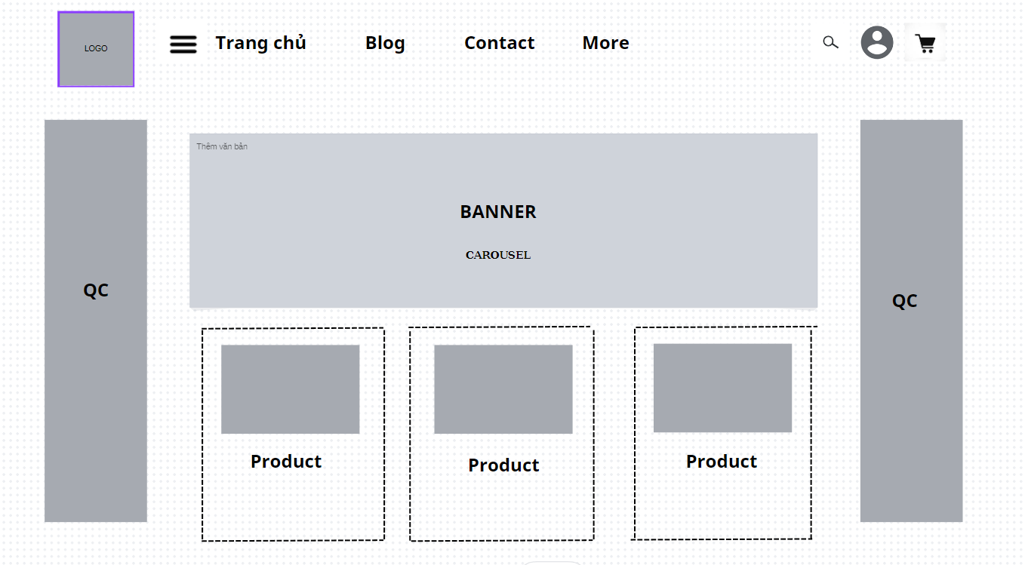

### https://lh5.googleusercontent.com/EkykSjlTvZLQIPrGtFfwuY_Dad-VwX-sIPq3F1ETR-CHAMILKo4nWsyD0AKwMZgettRhmgMhsVTNU4BOT1VG_arbzJTy6Ulz2XJeU_n0uojFAVyyBWdtiy5QhMaEl18CUZL4sXMUpkgerXmMFPvldxo

### b. Blog List

* Function trigger: This function is triggered when the user clicks blogs in navbar
* Function description: Show the paginated list of blogs
* Screen layout: mock-up prototype of the screen, sample below is for the Blog screen

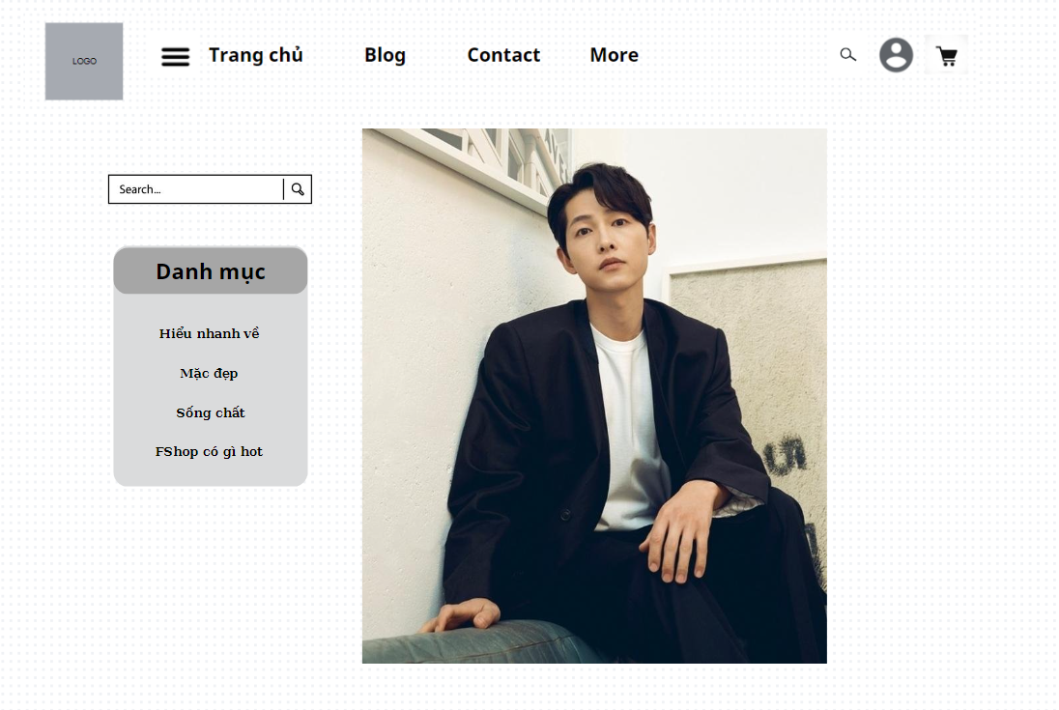

- Function Details:

* Show the posts pagination (sorted by updated date)
* The left sider with the post search box, post categories, five featured posts (thumbnail, title)
* Post information includes its thumbnail, title, category, post date, brief-info

### c. Blog Details

  - Function trigger: This function is triggered when the user clicks to Image or Title

- Function description: Show detail information of blog

- Screen layout: mock-up prototype of the screen, sample below is for the Details screen

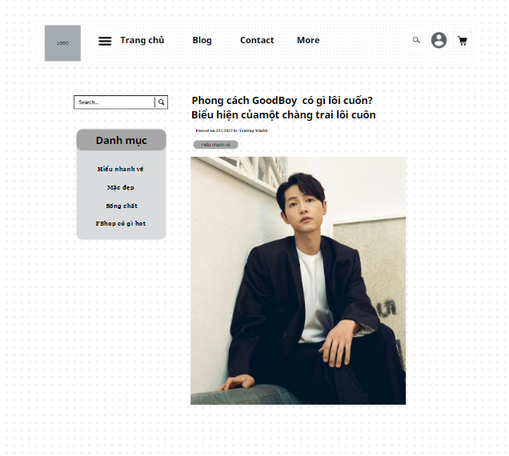

- Function Details:

* Show post details (including title, author, updated date, brief info, and post content)
* The left sider with the post search box, post categories

### d. Products List

- Function trigger: This function is triggered when the user clicks to Product( Sản Phẩm) on header.

- Function description: Show the products paginated (sorted by updated date) + the slider with the product search box, product categories, the latest products, and static contacts/links

* Shown product information includes its thumbnail, title, brief information, original price, and sale price.
* The user is redirected to the product's details on his/her clicking on the product.
* The user can choose to add the product to the cart or to feedback on the product by clicking the product's Buy & Feedback buttons responsively.
* Screen layout: mockup prototype of the screen, sample below is for Product list screen

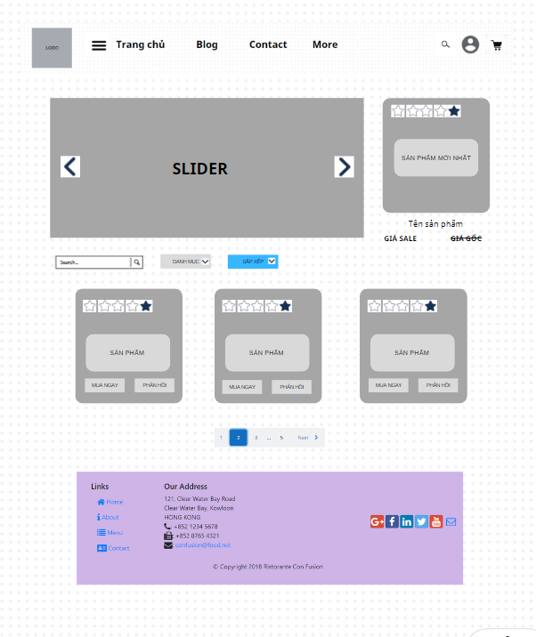

* Function Details: When the page loads for the first time, it will display all the products, categories, and sliders in the database.
* When clicking on the search bar, the keyword will be transmitted for processing and will return the product page containing that keyword.
* When clicking on the dropdown for the category, selecting a category in it, the page will return products with the same selected category.
* When clicking on the dropdown for sorting, choosing a sort, the page will return the products after being sorted according to that selection.
* Clicking on a specific product will take you to the Product detail screen for that product.
* When clicking buy now, the product will be added 1 time to the cart.
* Clicking on the feedback will be taken to the feedback screen for that product.

### e. Product Details

### Activate the function: This function is activated when the user clicks on the Product.

### Function Description: Display user clicked products on product page + slider with product search box, product category, latest product and contact/static link

### Product information displayed includes thumbnail, title, details, original price and special price, quantity, color, size.

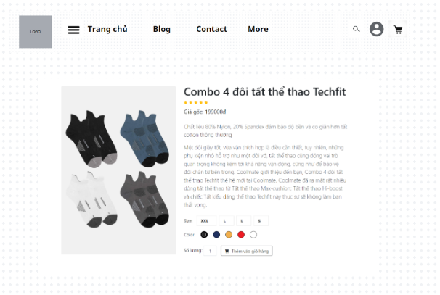

### The user can choose to make a purchase or add the product to the cart.

### Related products displayed by product category have the same functions as in the Product List page

### Screen layout: The template above is for product detail, the template below is for related product list screen

### f. Cart Details

Trigger function: This function is triggered when user clicks on the cart icon.

Function Description: Display user clicked products in header bar + slider with product search box, product category, latest products and contact/static link

The product information displayed includes thumbnail, name, original and discounted price, quantity, total price of the unit and total price of the products.

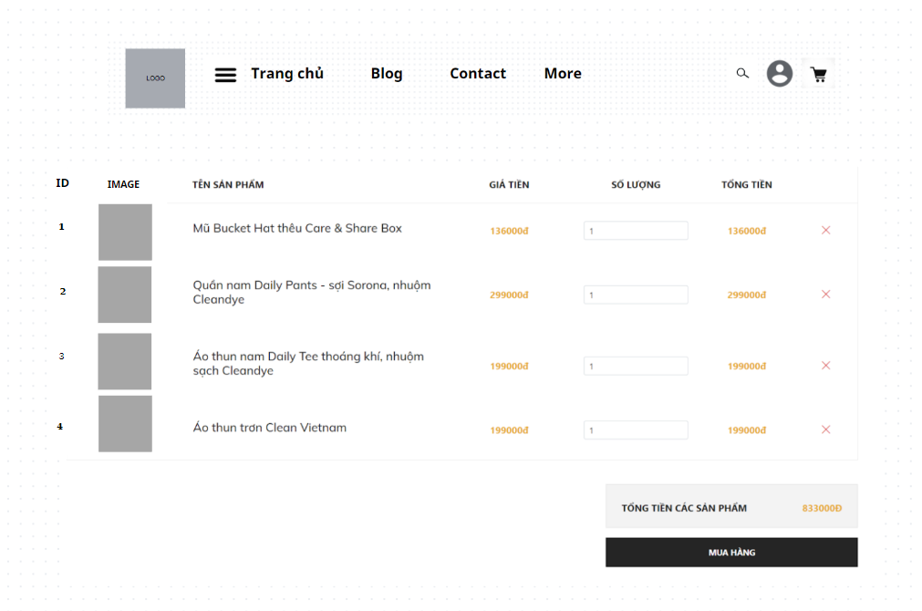

The user can choose to checkout or remove the product from the cart.

Related products are displayed in the order the user clicks add to cart

Screen Layout: The template above is for the header of the page, the template below is for the products added to cart screen, and the last one shows the total price details of the products in the cart, to the user. proceed to payment

### g. Cart Contact

Activation function: This function is activated when the user clicks the purchase button on the Cart Detail page

Function Description: Displays the products clicked by the user in the title bar. Related products are displayed in the order the user clicks add to cart

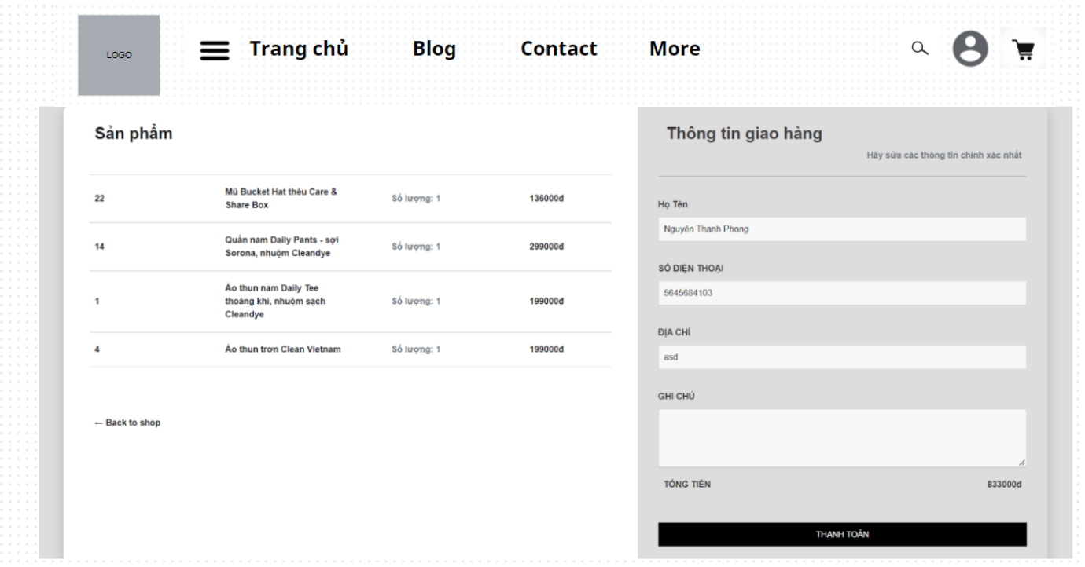

The displayed product information includes the name, final price, quantity, total price of the unit, and the total price of the product.

Shopper information is taken from the user's settings, which can edit the destination and notes for the product.

Screen layout: The template above is for the title of the page, the form below is divided into 2 halves, the left is for product information, the right is for customer information and total price details of the products. in the cart with a payment button for the customer to pay for the ordered item.

### h. Cart Completion

- Function trigger: This function is triggered when the user clicks to Submit( Gửi thông tin)after entering contact information in cart contact.

- Function description: This page show the cart completion notes + the slider with the product search box, product categories, the latest products, and static contacts/links; Before this page is shown:

* The Order status is changed to submitted.
* The product's available quantities are updated accordingly.
* The submitted order is assigned automatically to the active salers rotatedly.
* If the receiver information (name, email, mobile, gender) is new or changed (checking via the email0, the latest receiver information is stored in the system as latest & historical system contact information (for the marketing's reference later).
* The customer/user would receive the order confirmation & payment guides via his/her email. That information is shown on the page also. The payment information (banking account,...) are taken from the system configuration file.
* Screen layout: mockup prototype of the screen, sample below is for Cart completion screen

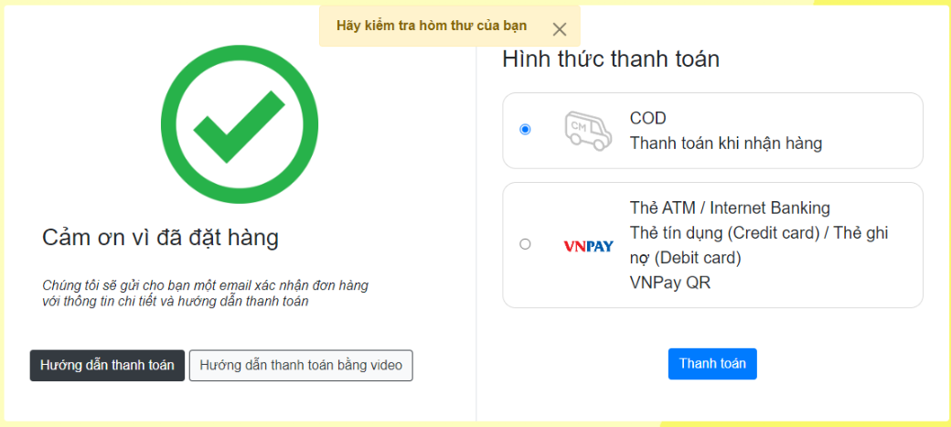

* Function Details: When the page loads for the first time, it will display a successful email message and payment instructions.
* When you click pay after receiving the goods and click pay, the order will be updated to the corresponding status and redirected to the home page.
* When clicking pay with Vnpay and clicking pay, enter information to pay when integrating Vnpay. After completing the payment, the order will be updated with the status and returned to the home page.

### j. Feedback

**- Function trigger**: This function is activated when the user clicks on the product image (When the product has been successfully purchased, it will show ) from the details of a product.

**- Function description**:Users can give general or specific feedback on a product with information: content, image, star ratings.

**- Screen layout**: simulated prototype of screen, below sample is for Feedback screen

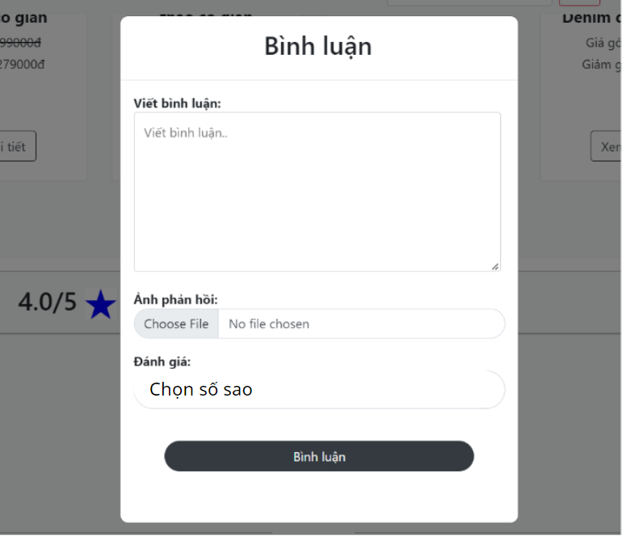

* **Function Details**: After a successful purchase, the user receives a link to the purchased product feedback. Here users can comment on purchased products, about the store or can submit comments when clicking the "Gửi ý kiến" button at the footer bar including: content, image, number of review stars (Content and number star rating cannot be empty) to submit a comment click the button “Bình luận”. The content displayed includes: username, rating stars, content, image, comment date, and users can delete their own comments when clicking the button “Xóa”.

## 2. Common Feature

### a. User Login

**- Function trigger:** This function is triggered when the user clicks “Đăng Nhập” form “Trang Chủ”

**- Function description:** User sign in into the system.

**- Screen layout:** mock-up prototype of the screen, sample below is for the Login screen

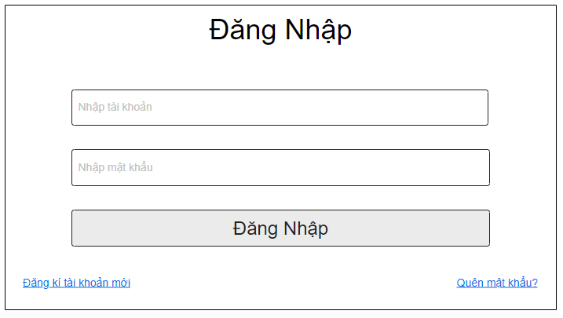

* **Function Details**:
* When the page loads for the first time, it will display the homepage.
* When clicking on the login button on the homepage, have a login pop-up.
* When entering username and password, then click on button login.
* If username or password are correct, the page will return homepage and have a button logout.
* If username or password are incorrect, have a notify "Username or password are incorrect"
* Clicking on "Quên mật khẩu" will take you to the reset password screen for user.
* Clicking on "Đăng ký" will take you to the register screen for users.

### b. User Register

**- Function trigger:** This function is triggered when the guest goes to login and choose to register

**- Function description:** The guest can create an account.

**- Screen layout:** mock-up prototype of the screen, sample below is for the Register.

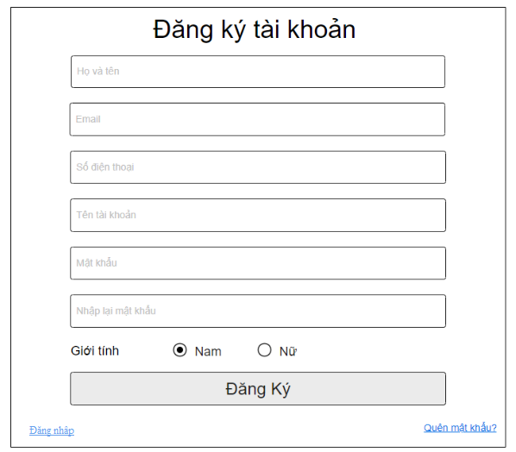

* **Function Details**:
* When the page loads for the first time, it will display the homepage.
* When click on button login on homepage, have a login pop-up, and click on button register to have a register pop-up
* When entering username and password, then click on button login.
* If username or password doesn't exist, the page will return homepage and have a button logout.
* If username exist, have a notify "Username exist"
* If password and re-password aren't the same, have a notify "password and repassword aren' the same"
* Clicking on "Quên mật khẩu" will take you to the reset password screen for user.
* Clicking on "Đăng nhập" will take you to the login screen for the user.

### c. Reset Password

**- Function trigger**: This function is triggered when the user clicks “Quên mật khẩu” form Đăng nhập

**- Function description**: The user can Reset Password to an account.

**- Screen layout**: simulated prototype of screen, below sample is for Reset Password screen

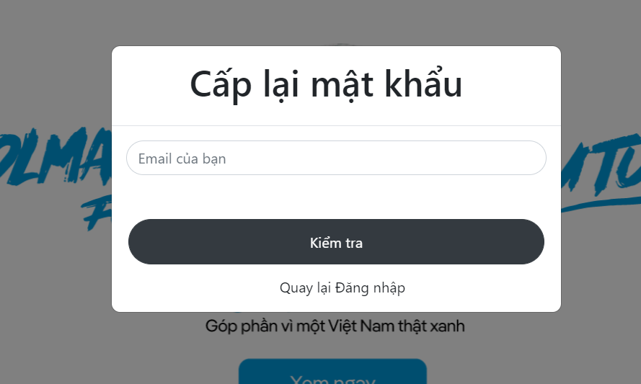

**- Function Details**:User enters his email, clicks "Kiểm tra" button to receive password reset link.If email does not exist in the shop, will receive notification and be allowed to re-enter. When entering the correct email registered with the shop, this link is sent to the user's email to reset their password.

- When clicking on the link, the user is directed to the reset password page with the old password,

where they enter the new password (twice) to access the system and return to the home page

### d. Change Password

**- Function trigger**: This function is triggered when the user clicks “Thông tin cá nhân” from UserName in Homepage

**- Function description**:User to change his password by entering current password as well as new password (twice)

**- Screen layout**: simulated prototype of screen, below sample is for Change Password screen

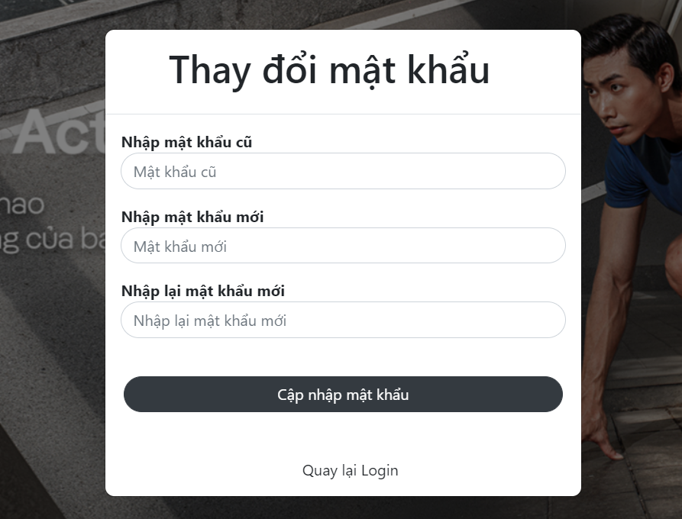

**- Function Details**: The user enters the old password and enters the desired new password (twice), then clicks the "Cập nhập mật khẩu" button. If the old password is wrong, the 2 new passwords are not the same or the password is > 32 characters or <= 8 characters will receive a notification. When the old password is entered correctly and the two new passwords are the same, the password change is successful

### e. User Profile

**- Function trigger**: This function is triggered when the user clicks “Tài khoản của tôi” from Home

**- Function description:** The user can edit his/her profile information, including the registered user information and the avatar image.

**- Screen layout:** simulated prototype of screen, below sample is for User profile screen

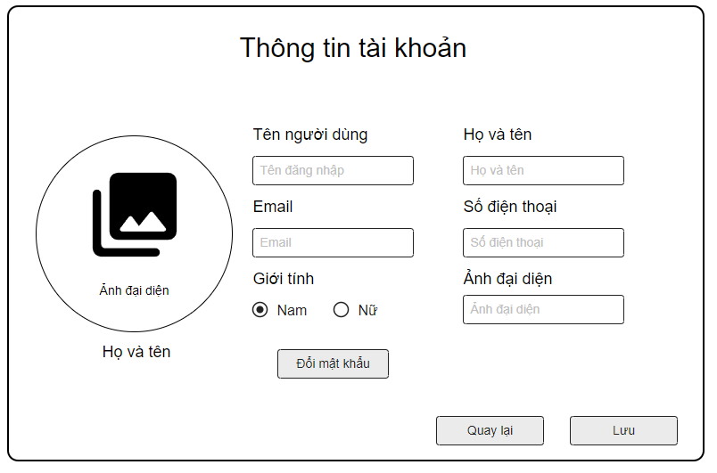

* **Function Details**:
* The user can edit his/her profile information.
* Clicking on "Đổi mật khẩu" will take you to the change password screen for user.
* Clicking on "Lưu" will take you to save information for the user.
* Clicking on "Quay lại" will take you to the homepage screen for the user.

### f. User Authorization

**- Function trigger**: This function is activated when the user is not logged in, tries to log in by directly entering the access link to the disallowed page, the page does not match the role of the account.

**- Function description**:The user intentionally logged in to the disallowed page with a direct address, delegating the user to the allowed page

**- Screen layout**: simulated prototype of screen, below sample is for User Authorization screen

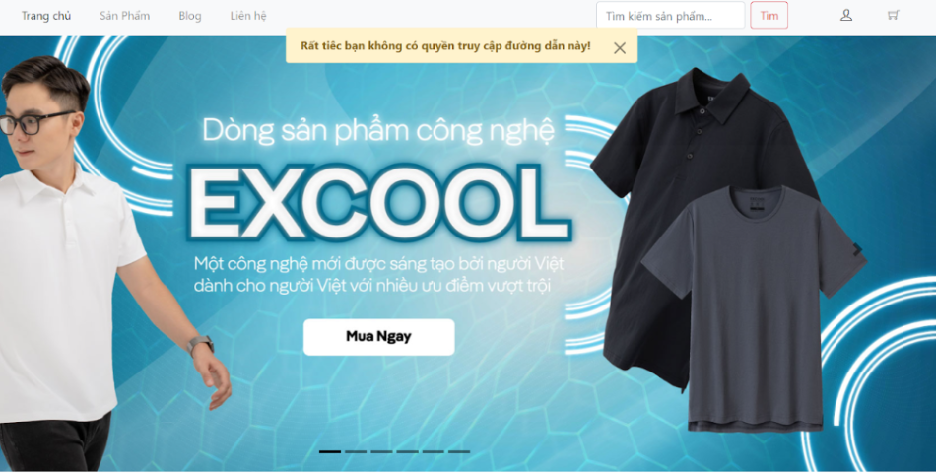

**- Function Details**: When the user logs in will be returned to the permission page with the role of the account. If the user intentionally visits the disallowed page or enters the address directly, the disallowed links will not be able to access and receive the notification.

## 3. Admin Feature

### a. Admin Dashboard

- Function trigger: This function is triggered when the user clicks the Manage system( Quản lý hệ thống) on header.

- Function description: Show statistics of new orders (success, canceled, submitted), revenues (total, by product categories), customers (newly registered, newly bought), feedbacks (average star: total, by product categories) & the trend of order counts (success, all) by day for the last 7 days (the start date & end date can be adjustable).

- Screen layout: mockup prototype of the screen, sample below is for Admin Dashboard screen

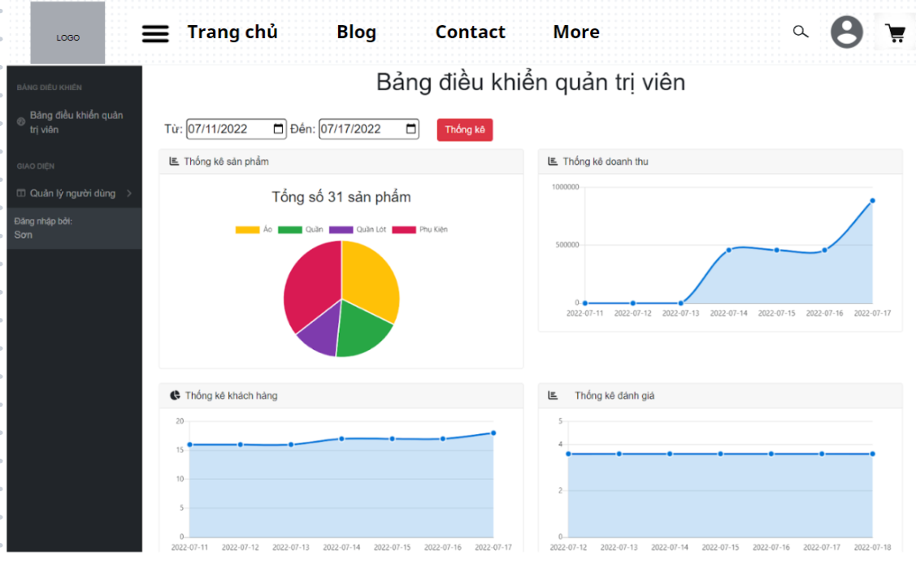

* Function Details:
* When the page loads for the first time, it will show all statistics of new orders (success, canceled, submitted), revenues (total, by product categories), customers (newly registered, newly bought), feedbacks (average star: total, by product categories) & the trend of order counts (success, all) by day for the last 7 days.
* When editing the start and end dates and press the submit button. it will show all the statistics of new orders (success, canceled, submitted), revenues (total, by product categories), customers (newly registered, newly bought), feedbacks (average star: total, by product categories) & the trend of order counts (success, all) by day for the last 7 days according to the date entered..

### b. Users List

- Activation function: This function is activated for the account that has been authorized as admin and when clicking on user management.

- Function description: 'Displays a paginated list of registered users (including user id, full name, gender, email, mobile phone, role, status):

- Admin can filter users by gender, role, status

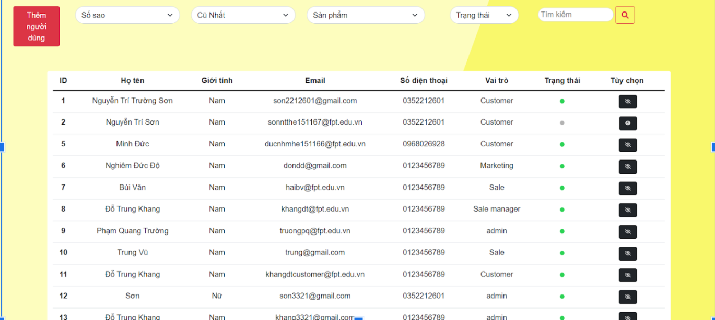

* Allow admin to search users by name, email, mobile phone
* List can sort by id, name, gender, email, mobile, role, status
* From each user, admin can choose to view or edit it
* The page also has a button/link that allows admins to add new users
* Screen layout: The template above is for the page title, the one below is for displaying the details of the user's information, filtering the information in the user list, and editing the user's status edit button .

### c. User Details

…

### d. Settings List

- Function trigger: This function is triggered when the user clicks to the Settings  list( Danh sách cài đặt) on the left menu.

- Function description: Show the paginated list of settings (include settings' id, type, value, order, status):

* The admin can filter the setting by type, status.
  + Allow the admin to search settings by value.
  + The list is sortable by id, type, value, order, status.
  + From each setting, the admin can choose to view, activate/deactivate, or edit it.
  + The page also has the button/link that allows the admin to add a new setting.
* Screen layout: mockup prototype of the screen, sample below is for Settings list screen

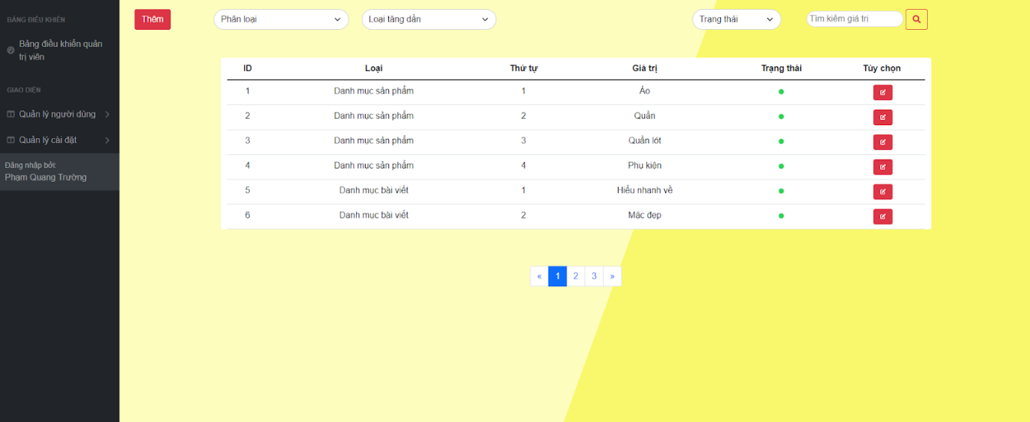

* Function Details: When the page loads for the first time, it will display all the settings, type in the database.
  + When clicking on the search bar, the keyword will be transmitted for processing and will return the settings page containing that keyword.
  + When clicking on the dropdown for the type, selecting a type in it, the page will return settings with the same selected category.
  + When clicking on the dropdown for sorting, choosing a sort, the page will return the settings after being sorted according to that selection.
  + When clicking on the dropdown to filter the status, select a category, the page will return the settings after sorted by that selection
  + Clicking on a specific setting or edit icon will take you to the Product detail screen for that product.
  + Click the "Thêm" button to add 1 new setting..

### e. Setting Details

- Function trigger: This function is triggered when the user clicks to Setting specific or edit icon on Settings list.

- Function description: Show detailed setting information (type, value, order, description, status), from that allow the user to add new, view or edit setting information.

- Screen layout: mockup prototype of the screen, sample below is for Setting Details screen

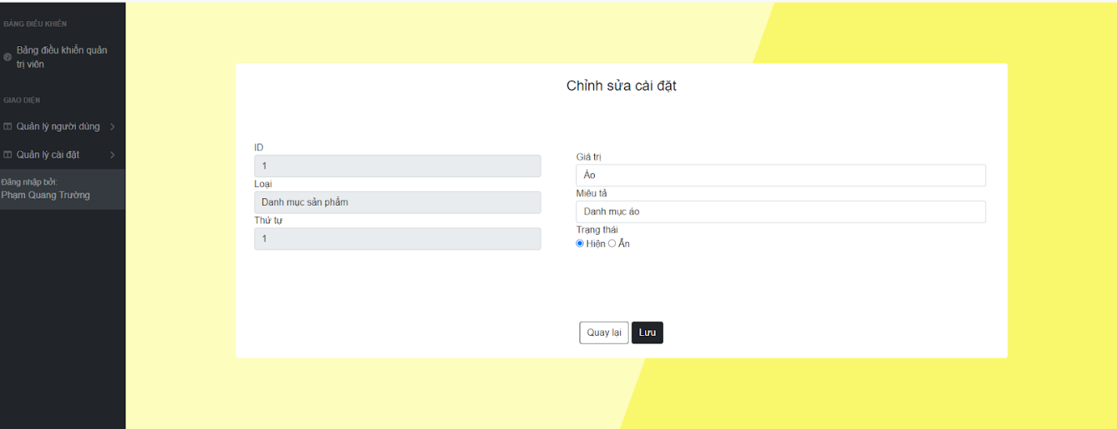

- Function Details: When the page loads for the first time, it will display all information of specific settings in the database.

* + When entering the title cannot be left blank otherwise a message will be displayed..
  + When clicking the "Quay lại" button, return to the previous post list page.
  + When clicking the "Lưu" button will save new information in the database.

## 4. Admin & Staff Dashboard

### a. Admin  Dashboard

* Function trigger: This function is triggered when the user clicks to Manage marketing( Quản lý tiếp thị) on header.
* Function description:Show statistics of posts, products, customers, feedback & the trend of new customers by day for the last 7 days (the start date & end date can be adjustable).
* Screen layout: mockup prototype of the screen, sample below is for MKT Dashboard screen

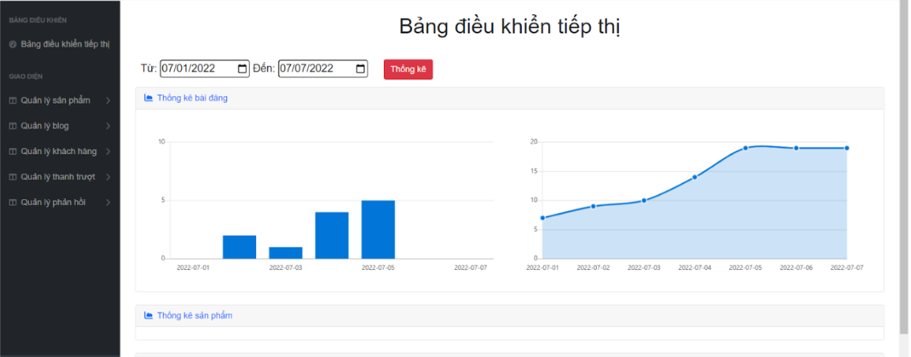

* Function Details: When the page loads for the first time, it will show all statistics of posts, products, customers, feedback & the trend of new customers by day for the last 7 days.
  + When editing the start and end dates and press the submit button. it will show all the statistics of new customer posts, products, customers, feedback and trends according to the date entered.

### b. Posts List

* Function trigger: This function is triggered when the user clicks to the Posts list( Danh sách bài đăng) on the left menu.
* Function description: Show the paginated list of posts (include posts' id, thumbnail, title, category, author, featured, and status information):
  + The user can filter the post by category, author, status or search by title.
  + Sortable by title, category, author, featured, or status.
  + From each post, the user can choose to hide, show, view, edit it.
  + The page also has the button/link that allows the user to add a new post.
* Screen layout: mockup prototype of the screen, sample below is for Posts list screen

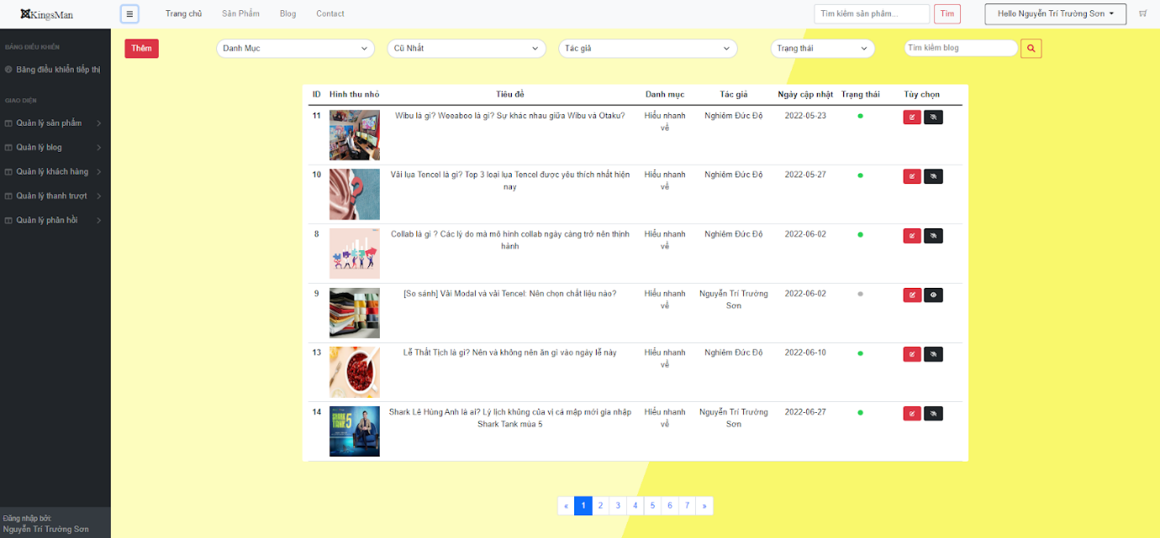

* Function Details: When the page loads for the first time, it will display all the posts, categories, and authors in the database.
  + When clicking on the search bar, the keyword will be transmitted for processing and will return the posts page containing that keyword.
  + When clicking on the dropdown for the category, selecting a category in it, the page will return posts with the same selected category.
  + When clicking on the dropdown for sorting, choosing a sort, the page will return the posts after being sorted according to that selection.
  + When clicking on the dropdown to filter by author, select a category, the page returns the posts after being sorted by that selection.
  + When clicking on the dropdown to filter the status, select a category, the page will return the posts after sorted by that selection
  + Clicking on a specific post or edit icon will take you to the Product detail screen for that product.
  + Clicking on the eye icon will change the specific post status..
  + Click the "Thêm" button to add 1 new post..

### c. Post Details

* Function trigger: This function is triggered when the user clicks to Post specific or edit icon on Posts list.
* Function description: Show detailed post information (thumbnail, category, title, brief information,  description, flag to turn the featurning on/off, status), from that allow the user to input, view or edit them.
* Screen layout: mockup prototype of the screen, sample below is for Post Details screen

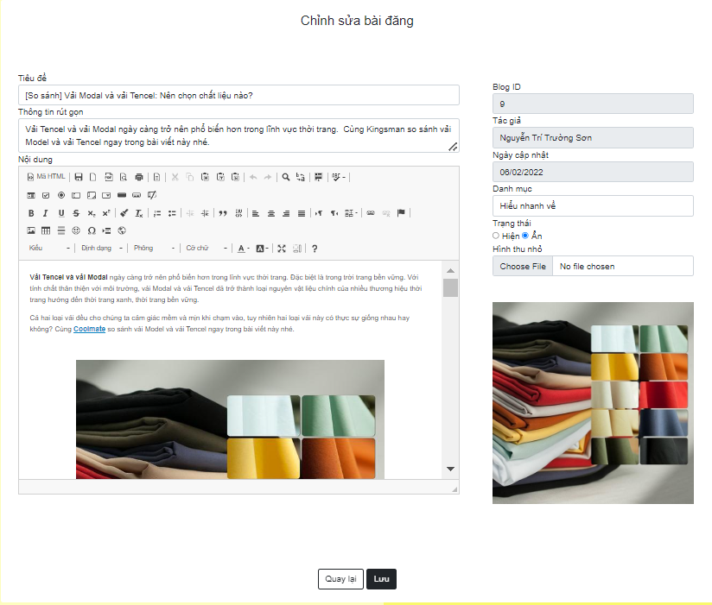

* Function Details: When the page loads for the first time, it will display all information of specific posts in the database.
  + When entering the title cannot be left blank otherwise a message will be displayed..
  + When clicking the "Quay lại" button, return to the previous post list page.
  + When clicking the "Lưu" button will save new information in the database.

### d. Sliders List

* **Function trigger**: This function is activated when the user logs in with the marketing role, clicks the "Manage Marketing" button at the account name displayed on the Home page, selects the item "Manage slider", then select "Slider List";
* **Function description**:Display slider information including titile, image, backlink, status and can filter by them. You can also add and edit sliders in this.
* **Screen layout**:mock-up of the screen, the sample below is for the Slider List screen

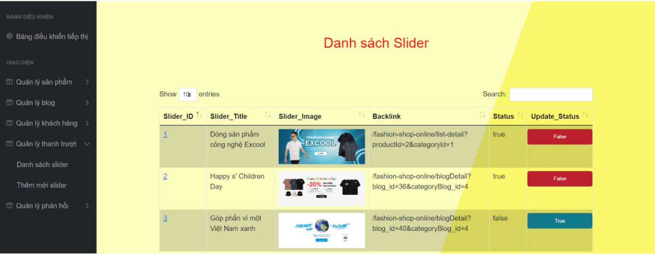

* **Function Details**:

- Users can add sliders at the "add new slider" section

- User can update the status of the slider

- User can edit slider

- User can sort each item in slider by clicking on each item name in slider

### e. Slider Details

* **Function trigger**: This function is activated when the user logs in with the marketing role, clicks the “Manage Marketing” button at the account name displayed on the Home page, selects the item “Manage sliders”, selects the option “List  slider ” and click the ID of any slider
* **Function description**:Display slider information including titile, image, backlink, status.
* **Screen layout**:mock-up of the screen, the sample below is for the Slider Detail screen

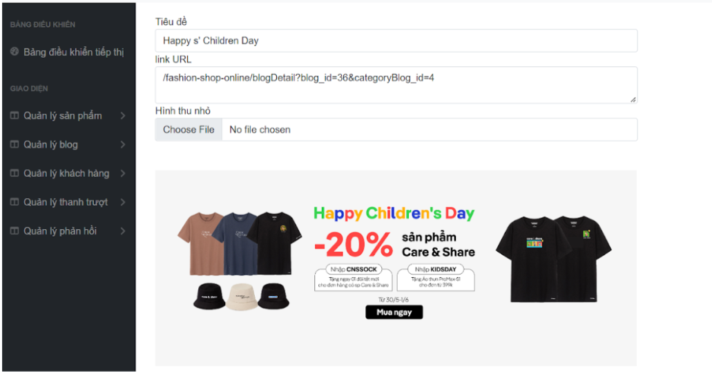

* **Function Details**:

 Users can view slider details (title, image, backlink) and can also edit it here.

### f. Products List

* **Function trigger**: This function is activated when the user logs in with the marketing role, clicks the "Quản lý tiếp thị" button at the account name displayed on the Homepage, selects the "Quản lý sản phẩm" section, then "Danh sách sản phẩm";
* **Function description**:Display paginated product information including: id, status, photo, category, product name, original price, promotional price, quantity, search bar, product filtering by category, status , price, date, number of products available, number of products in the store
* **Screen layout**: simulated prototype of screen, below sample is for Product List screen

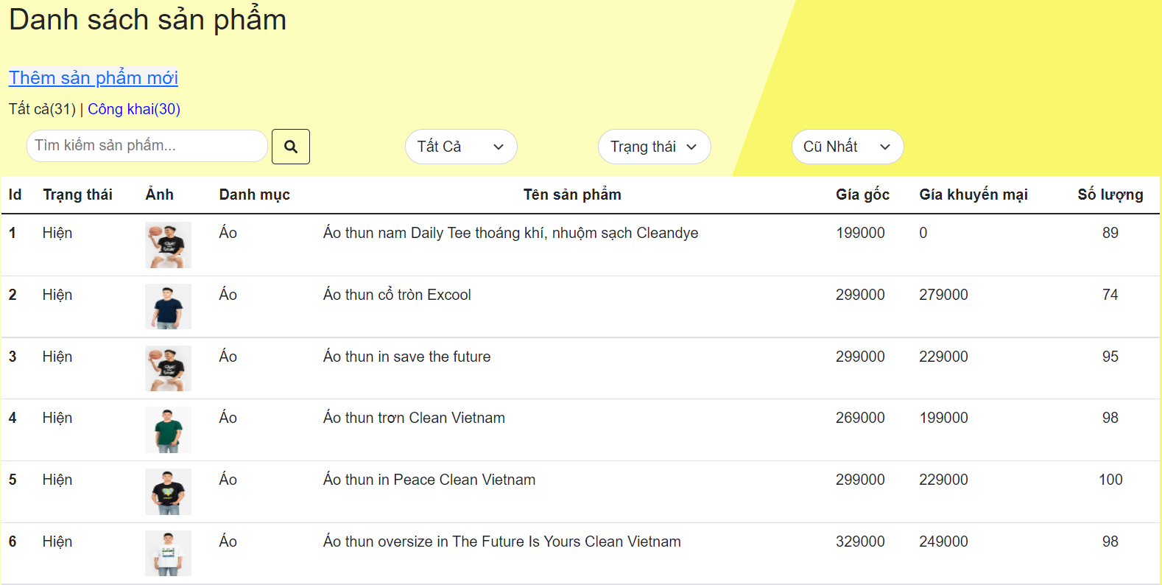

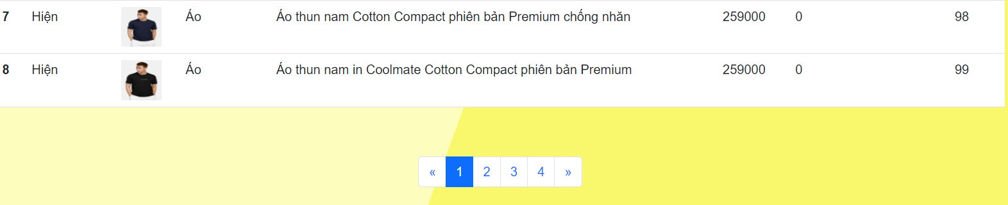

* **Function Details**:

 -Users can add new products at the "Thêm sản phẩm mới" button.

-Users can search for products by entering what they want to search for, then clicking the search icon. The list will display the products containing the imported content.

-Users can filter products by category at the "Tất cả" button. The list will display the products in the selected category.

-Users can filter products by status at "Trạng thái" button. The list will show the products according to the selected status.

-Users can filter products by date, price at the "Cũ nhất" button. The list will display the products by selection ("Mới nhất",”Giá tăng dần”,”Giá giảm dần”).

-User can display the product list by paginated page number when clicking on the page number or the << button to go back 1 page, >> to move forward 1 page

### g. Product Details

* **Function trigger**: This function is activated when the user is logged in with the marketing role, in the "Danh sách sản phẩm" section, click the "Thêm sản phẩm mới" button to add a new product, click the product image to display detailed information about the product , can edit
* **Function description**:

- When clicking the "Thêm sản phẩm mới" button, a form will be displayed including: product name, photo address, original price, promotional price, title, description, status, quantity, category with blank content, "Thêm" button and "Quay lại" button.

- When clicking on the product image, the form includes: product name, photo address, original price, promotional price, title, description, status, quantity, category with product's content, Button "Cập nhật" and "Quay lại" button.

* **Screen layout**: simulated prototype of screen, below sample is for Product Details screen:

-Add new product:

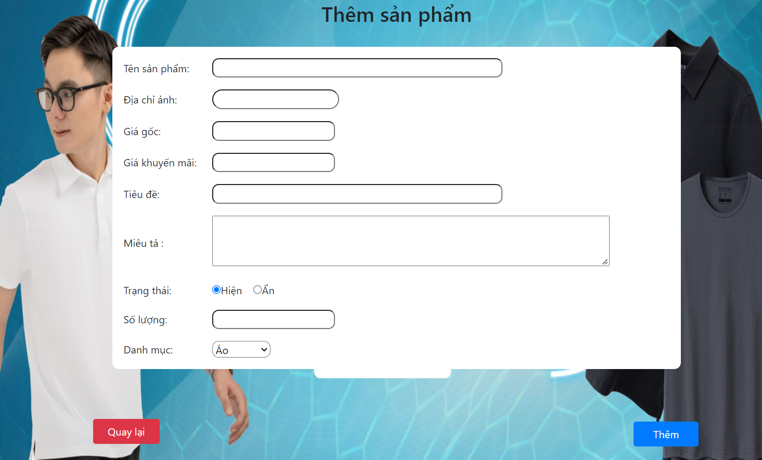

-Edit product:

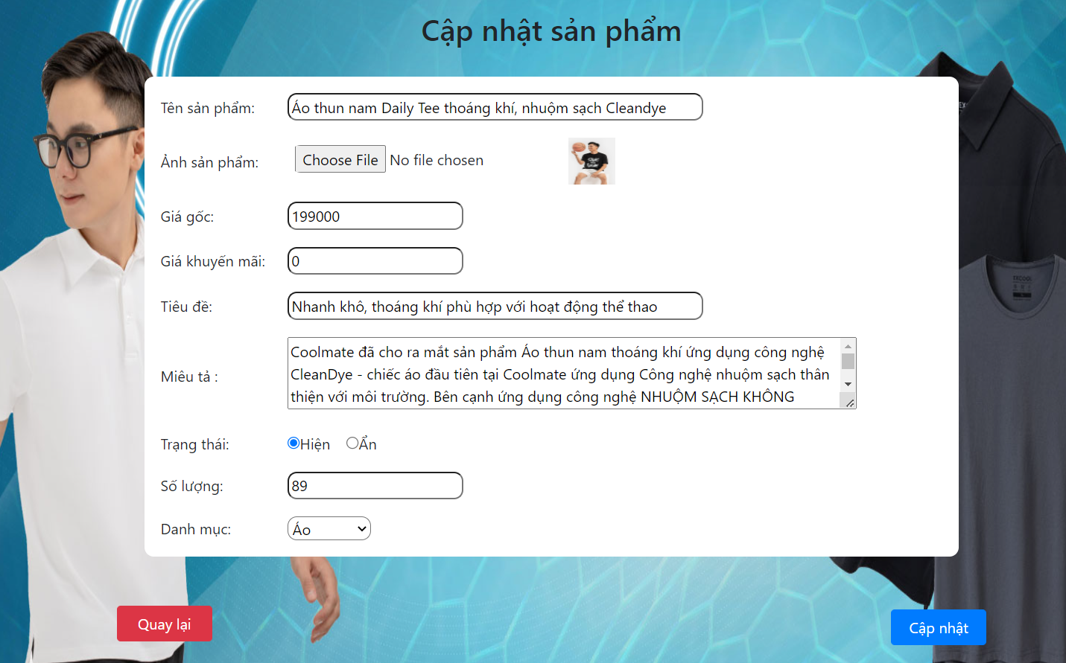

* **Function Details**:

 -After clicking the "Thêm sản phẩm mới" button, it will lead to a new product page with information: product name, photo address, original price, promotional price, title, description, status, quantity, category with product's content is empty. The user needs to enter all the information of the product, then click the "Thêm" button to add a new product, click the "Quay lại" button to return to the product list page.

-After clicking on the product image, it will lead to the product update page with the following information: product name, photo address, original price, promotional price, title, description, status, quantity, category with product's content. User can edit product information, then click "Cập nhật" button to update product, click "Quay lại" button to return to product list page.

### h. Customers List

* Function trigger: This function is triggered when the user clicks to the Customers list( Danh sách khách hàng) on the left menu.
* Function description: Show the list of customers / contacts paginated (include contacts' id, full name, gender, email, mobile, status):
  + The user can filter the customers by status + search by full name, email, mobile.
  + Sortable by full name, email, mobile, status.
  + From each customer, the user can choose to view or edit it.
* Screen layout: mockup prototype of the screen, sample below is for Customers list screen

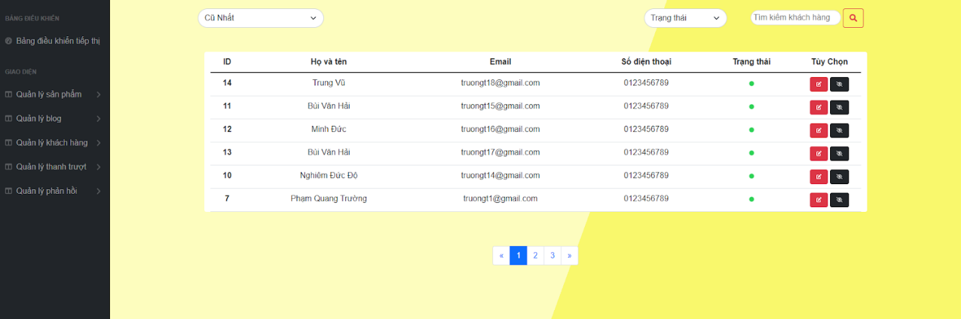

* Function Details: When the page loads for the first time, it will display all the customers in the database.
  + When clicking on the search bar, the keyword will be transmitted for processing and will return the customers page containing that keyword.
  + When clicking on the dropdown for sorting, choosing a sort, the page will return the customers after being sorted according to that selection.
  + When clicking on the dropdown to filter the status, select a category, the page will return the customers after sorted by that selection
  + Clicking on a specific customer or edit icon will take you to the Customer detail screen for that customer.
  + Clicking on the eye icon will change the specific customer status..

### j. Customer Details

* Function trigger: This function is triggered when the user clicks to Customer specific or edit icon on Customers list.
* Function description: Show detailed customer/contact information (full name, gender, email, mobile, address, status):
  + From that allow the user to input, view or edit them (for the status which is generated automatically - contact, potential or customer)
  + Besides, the screen also shows the list of customer/contact changes history in the form of a table which includes following columns: email, full-name, gender, mobile, address, updated by, updated date
* Screen layout: mockup prototype of the screen, sample below is for Customer Details screen

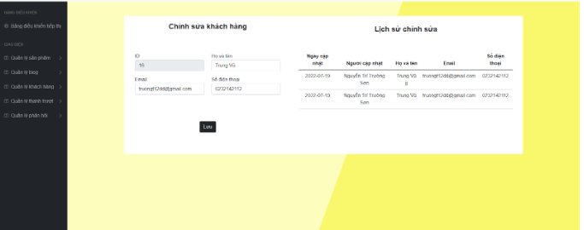

* Function Details: When the page loads for the first time, it will display all information of specific customers in the database.
  + When entering the title cannot be left blank otherwise a message will be displayed..
  + When clicking the "Lưu" button will save new information in the database..

### k. Feedbacks List

Trigger function: This function is fired when the user clicks on the response list in the dashboard.

Function description: Displays a paginated list of responses (including response contact name, product name, star rating, status):

Users can filter feedback by status, product, star rating + search by name, response content

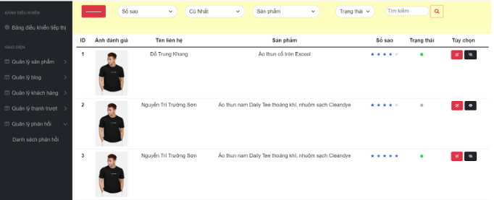

Can sort by full name, product name, star rating, status

From each response, the user can choose to view or change its status

Screen layout: The template above is for the title of the page, the template below is to display details of user reviews, filter reviews, filter reviewer names in the review list, and more edit button edit user's status, details of that review.

### l. Feedback Details

Trigger function: This function is triggered when user clicks details button in Marketing feedback list page.

Function description: Show feedback details (contact name, email, mobile, product, star rating, feedback, image status) and user feedback image

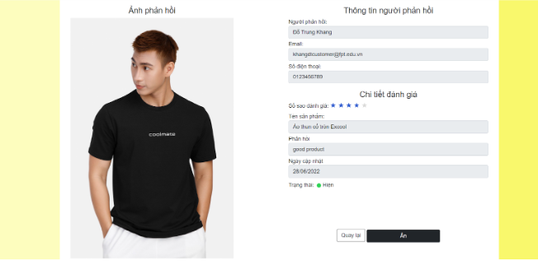

Bố cục màn hình: Mẫu bên trên dành cho tiêu đề của trang, mẫu bên dưới được chia làm 2 nửa. Bên phải hiện thị hình ảnh phản hồi của người dùng. Bên trái  phía trên hiển thông tin người dùng phản hồi (họ tên, email, số điện thoại) , ở giữa hiển thị chi tiết đánh giá (Số sao đánh giá, phản hồi, sản phẩm được đánh giá, ngày người dùng đánh giá sản phẩm, trạng thái hiện tại của phản hồi và dưới cùng hiện thị 2 nút(1 là quay lại trang feedback list, 2 là nút ẩn trạng thái đánh giá của người dùng).

## 5. Customer Feature

### a. My Orders

* **Function trigger**: This function is activated when the user is logged in as a customer, in the "Hello Customer" section, clicks the "Order List" button to view the purchased orders and can cancel them.
* **Function description**:This function will list the orders you have placed (including purchase date, product, total cost, status) and you can modify their status.
* **Screen layout**: simulated prototype of screen, below sample is for My Order screen:

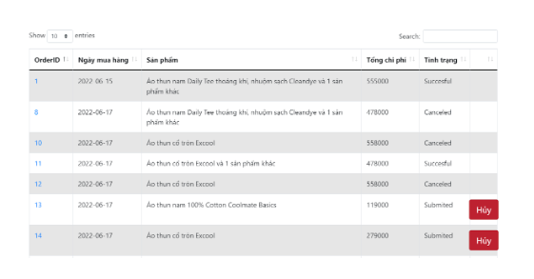

* **Function Details**:

This function will display a list of orders you have ever placed (including purchase date, product, total cost, status) and you can cancel orders by modifying their status.

You can also filter your orders by order by clicking on the order item name (ID, purchase date, product, total amount, status) and searching by them.

### b. Order Information

* **Function trigger**: This function is activated when the user logs in as a customer, in the "Hello Customer" section, clicks the "Order List" button and clicks on the order ID to view the details of the order. order (including product, cost and recipient).
* **Function description**:This function will display your order details (product, quantity, price, purchase date, recipient). Users can also repurchase products they have purchased and rate them.
* **Screen layout**: mockup prototype of the screen, the below sample is for the Order Detail screen:

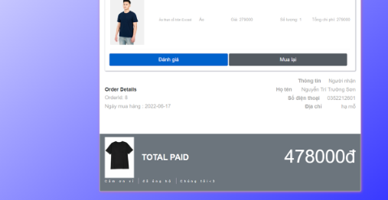

* **Function Details**:

Show the order details, including the information:

- The order id, order date, total cost, status

- The receiver information: full name, gender, email, mobile

- This list of ordered products, each product include following information & the links/buttons that allow the user to re-buy or feedback: thumbnail, name, category, unit price, quantity, total cost

## 6. Sale Feature

### a. Sale Dashboard

* Function trigger: This function is triggered when the user clicks to Manage Sale( Quản lý bán hàng) on the header.
* Function description:Show the trend of success/total orders, and the revenues trends by day for the last 7 days for all or a specific salesperson (the start date, end date, sale, order status can be adjustable).
* Screen layout: mockup prototype of the screen, sample below is for Sale Dashboard screen

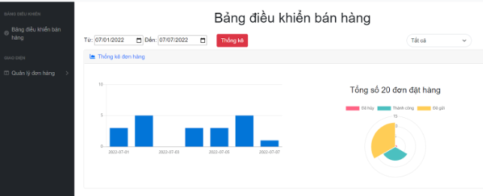

* Function Details: When the page loads for the first time, it will show all statistics, the trend of success/total orders, and the revenues trends by day for the last 7 days.
  + When editing the start and end dates and press the submit button. it will show all statistics, the trend of success/total orders, and the revenues trends by day according to the date entered.
  + When clicking on the dropdown to filter by author, select a category, the page returns all statistics, the trend of success/total orders, and the revenues trends by day according to the date entered.

### b. Orders List

* **Function trigger**: Activate the function: This function is activated when the user logs in with the sales role, clicks the "Sales management" button at the account name displayed on the Home page, selects the item "Manage orders", then select “Order List” ;
* **Function description**:Display a list of orders (ID, purchase date, product, total cost, Sales staff, order status) and saler can update order status.
* **Screen layout**:mock-up of the screen, the sample below is for the Order List screen

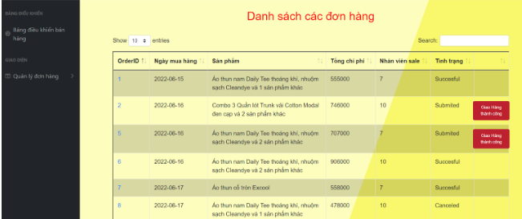

* **Function Details**:

-Show the list of orders paginated

- The list can be shorted by the order date, product name, total cost, status

- Each order include below information: id, ordered date, product (first product name & number of other products if any), total cost, status;

- Allow the users to filter the order by the order date, status

- Allow the user to search the orders by product name

- On clicking the link under the order id, user would be redirected to the Order Details page

### c. Order Details

* **Function trigger**: Activate the function: This function is activated when the user logs in with the sales role, clicks the "Sales management" button at the account name displayed on the Home page, selects the item "Manage orders", select “Order List” and then select to any ID in Order you want to view;
* **Function description**:Display order details (order date, product, price, customer information). Sales managers can change other Sales staff.
* **Screen layout**:mock-up of the screen, the sample below is for the Order Detail screen

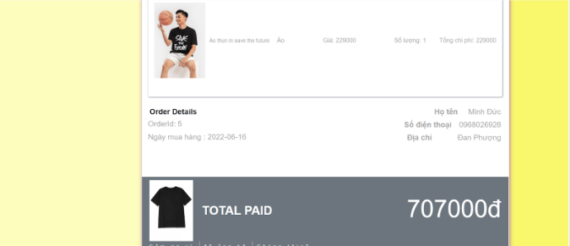

* **Function Details**:

Show the order details, including the following information:

- Basic order information: order id, customer full name, mobile, order date, total cost, sale ID, status

- The receiver information: full name, mobile, address

- This list of ordered products, each product include following information: thumbnail, name, category, unit price, quantity, total cost

Sale Manager can assign the order to other sale"